P5 Verilog流水线CPU设计文档

1. 模块与层次结构

本次CPU设计以Verilog单周期CPU（32位）设计为基础，旨在提高部件利用效率，将CPU设计成流水线，分为5个流水级，采用系统的层次化、结构化、流水级的设计，整体结构如下。可支持的指令集: **{addu, subu, ori, lw, sw, beq, lui, jal,jr,nop}。**

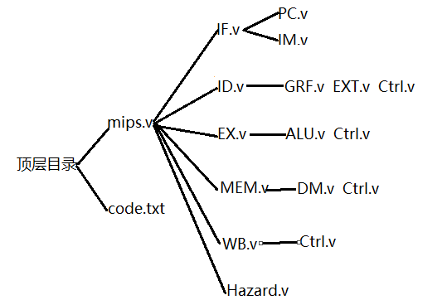

图1 CPU模块和层次

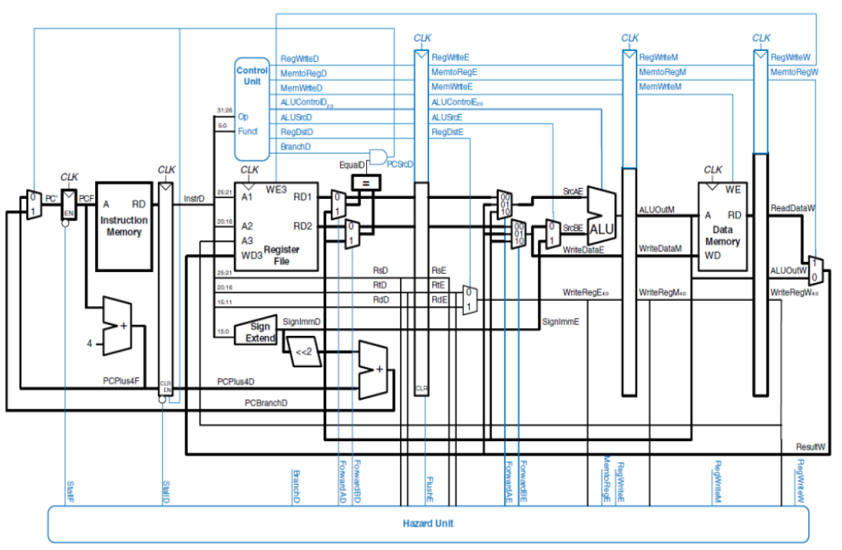

图2 CPU数据通路电路图

顶层文件mips.v模块接口定义：

表1 mips.v模块接口定义

|  |  |
| --- | --- |
| 文件 | 模块接口定义 |
| mips.v | module mips(clk, reset);  input clk,reset;//clk, reset |

1. 数据通路设计

由于P4已经完成相关设计，由此得出的数据通路图进行设计。数据通路分为5个流水级：IF.v, ID.v, EX.v, MEM.v, WB.v。分别搭建流水级，和各流水级所需要的部件，然后交给mips统一管理，自底向上设计。

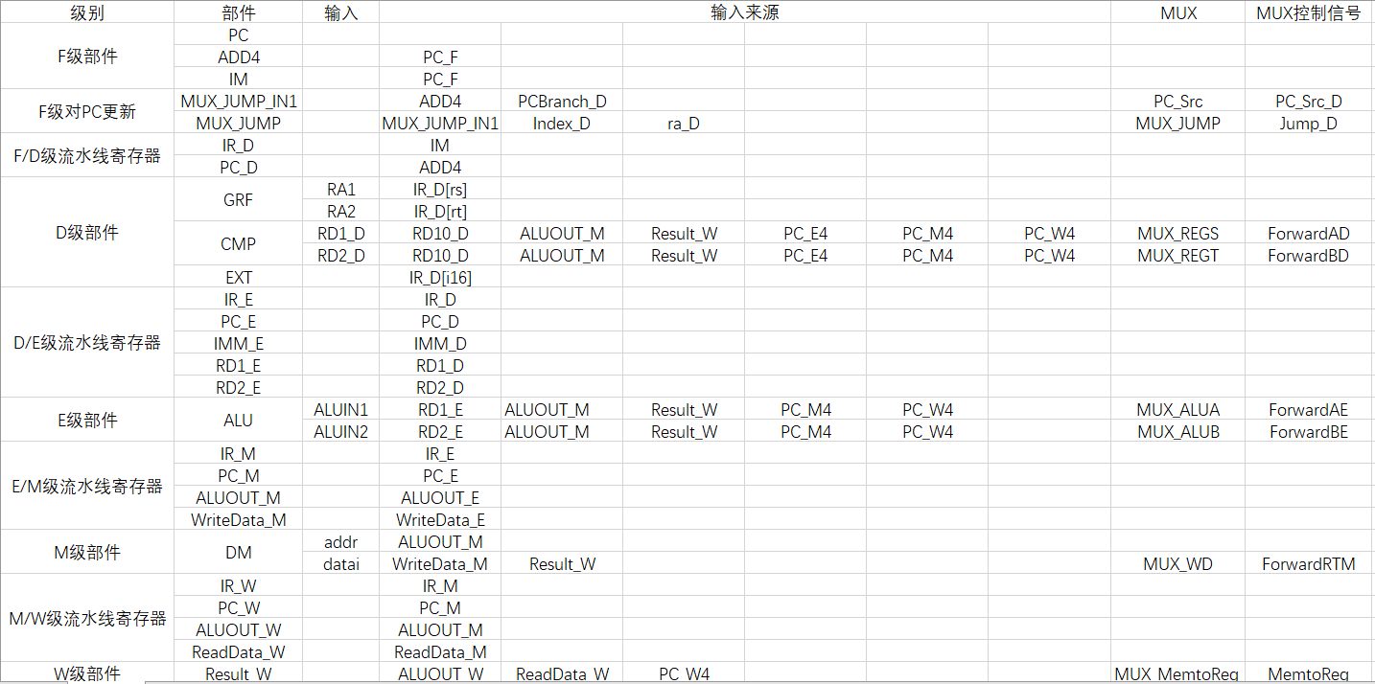

图3 CPU数据通路数据来源

IF.v模块接口定义：

表2 IF.v模块接口定义

|  |  |
| --- | --- |
| 文件 | 模块接口定义 |
| IF.v | module IF(clk,reset,en,PCSrc_D,PCBranch_D,Index_D,ra_D,Jump_D,PC_D,IR_D);  input clk,reset,en,PCSrc_D;//clk,reset,PC使能信号,PC跳转信号  input [31:0]PCBranch_D,Index_D,ra_D;//16位立即数偏转地址,26位立即数偏转地址,jr指令读取的寄存器存的地址  input [1:0]Jump_D;//J类跳转选择信号  output reg[31:0]PC_D,IR_D;//D级流水线寄存器,存入PC和指令 |

PC.v模块接口定义：

表3 PC.v模块接口定义

|  |  |
| --- | --- |
| 文件 | 模块接口定义 |
| PC.v | module PC(clk,reset,en,NPC, PC);  input clk,reset,en;//clk,reset,使能信号  input [31:0]NPC;//下一个PC地址的输入  output [31:0]PC;//当前PC地址的输出 |

IM.v模块接口定义：

表4 IM.v模块接口定义

|  |  |
| --- | --- |
| 文件 | 模块接口定义 |
| IM.v | module IM(PC,Instr);  input [31:0]PC;//current pc address  output [31:0]Instr;//binary instructions |

ID.v模块接口定义：

表5 ID.v模块接口定义

|  |  |
| --- | --- |
| 文件 | 模块接口定义 |
| ID.v | module ID(clk,reset,clr,PC_D,IR_D,ALUOUT_M,Result_W,RegWrite_W,WREG_W,PCBranch_D,ra_D,Index_D,PCSrc_D,Jump,RD1_E,RD2_E,IMM_E,IR_E,PC_E,ForwardAD,ForwardBD);  input clk,reset,clr;//clk,reset,流水线寄存器清零信号  input [31:0]PC_D,IR_D,ALUOUT_M,Result_W;//D流水级PC值，D流水级指令，M流水级的ALU计算结果，W流水级的写入寄存器堆的数据  input [4:0]WREG_W;//W级流水线得出的要写入数据的寄存器编号  input RegWrite_W;//W级流水线写寄存器使能信号  input [1:0]ForwardAD,ForwardBD;//GRF[rs],GRF[rt]和转发数据选择信号的输入  output reg[31:0]RD1_E,RD2_E,IMM_E,IR_E,PC_E;//E级流水线寄存器  output [31:0]PCBranch_D,ra_D,Index_D;//接入F级流水线的16位立即数得到的偏转地址，读rs寄存器得到的PC地址，26位立即数得到的偏转地址  output PCSrc_D;//接入F级流水线的PC选择信号  output [1:0]Jump;//接入F级流水线J类跳转选择信号 |

GRF.v模块接口定义：

表6 GRF.v模块接口定义

|  |  |
| --- | --- |
| 文件 | 模块接口定义 |
| GRF.v | module GRF(RA1,RA2,WA,WD,clk,reset,RegWrite,RD1,RD2); input [4:0]RA1,RA2,WA;//read address 1, read address 2, write address  input clk,reset,RegWrite;//clk, reset, GRF write enable  input [31:0]WD;//data to write  output [31:0]RD1,RD2;//the data of read address 1, the data of read address 2 |

EXT.v模块接口定义：

表7 EXT.v模块接口定义

|  |  |
| --- | --- |
| 文件 | 模块接口定义 |
| EXT.v | module EXT(imme,ExtOp,datao);  input [15:0]imme;//16位立即数的输入  input [1:0]ExtOp;//扩展选择信号,00:零扩展 01：符号扩展 10：低16位加载至高16位  output [31:0]datao;//扩展结果的输出 |

EX.v模块接口定义：

表8 EX.v模块接口定义

|  |  |
| --- | --- |
| 文件 | 模块接口定义 |
| EX.v | module EX(clk,IR_E,RD1_E,RD2_E,IMM_E,PC_E,WREG_M,Result_W,IR_M,ALUOUT_M,WriteData_M,PC_M,ForwardAE,ForwardBE);  input [31:0]IR_E,RD1_E,RD2_E,IMM_E,PC_E;//E级流水线指令，从GRF读出的两个数据，扩展后的立即数，E级流水线PC值  input [31:0]Result_W;//W级流水线写入寄存器堆的数据  input [1:0]ForwardAE,ForwardBE;//从GRF读出的两个数据和转发进来的数据的选择信号  input clk;//clk  output reg[31:0]ALUOUT_M,WriteData_M,IR_M,PC_M;//M级流水线寄存器：ALU计算结果，写入DM的数据，指令，PC值  output reg[4:0]WREG_M;//M级流水线寄存器存入要写入数据的寄存器编号 |

ALU.v模块接口定义：

表9 ALU.v模块接口定义

|  |  |
| --- | --- |
| 文件 | 模块接口定义 |
| ALU.v | module ALU(ALUctr,A,B,C);  input [1:0]ALUctr;//alu运算选择信号  input [31:0]A,B;//alu运算的输入数A，B，00：符号加法运算 01：符号减法运算 10：按位与运算  output [31:0]C;//alu运算结果的输出 |

MEM.v模块接口定义：

表10 MEM.v模块接口定义

|  |  |
| --- | --- |
| 文件 | 模块接口定义 |
| MEM.v | module MEM(clk,reset,IR_M,ALUOUT_M,WriteData_M,,Result_W,WREG_M,PC_M,ReadData_W,ALUOUT_W,WREG_W,IR_W,PC_W,ForwardRTM);  input clk,reset,ForwardRTM;//clk,reset,写入DM的数据的选择信号  input [31:0]ALUOUT_M,WriteData_M,IR_M,PC_M,Result_W;//M级流水线的ALU计算结果，写入DM的数据，指令，PC值，W级流水线写入寄存器堆的数据  input [4:0]WREG_M;//M级流水线写寄存器编号  output reg[31:0]ReadData_W,ALUOUT_W,IR_W,PC_W;//W级流水线寄存器，从DM读取的数据，ALU计算结果，指令，PC值  output reg[4:0]WREG_W;//W级流水线写寄存器编号 |

DM.v模块接口定义：

表11 DM.v模块接口定义

|  |  |
| --- | --- |
| 文件 | 模块接口定义 |
| DM.v | module DM(addr,datai,clk,reset,MemWrite,datao);  input [9:0]addr;//10位地址的输入  input [31:0]datai;//要存入datamemory32位数据的输入  input clk,reset;//clk, reset  input MemWrite;//写使能信号  output [31:0]datao;//32位数据的输出 |

WB.v模块接口定义：

表12 WB.v模块接口定义

|  |  |
| --- | --- |
| 文件 | 模块接口定义 |
| WB.v | module WB(ReadData_W,ALUOUT_W,WREG_W,IR_W,PC_W,RegWrite_W,Result_W);  input [31:0]ReadData_W,ALUOUT_W,IR_W,PC_W;//W级流水线从DM读取的数据，ALU计算结果，指令，PC值  input [4:0]WREG_W;//W级流水线写寄存器编号  output RegWrite_W;//W级流水线写寄存器使能信号  output [31:0]Result_W;//W级流水线写入寄存器的数据 |

1. 控制器设计

控制器延续之前的设计，增添了指令分类功能，控制的本质就是一个译码的过程，将指令包含的信息转为CPU各部分的控制信号，在Verilog中有多种实现方式，这里依旧采用与或门阵来实现。

表13 Controller信号说明

|  |  |  |
| --- | --- | --- |
| 序号 | 信号名称 | 功能描述 |
| 1 | Instr | 32位指令的输入 |
| 2 | RegDst | 选择寄存器堆(GRF)的写地址 00:rt 01:rd 10:31 |
| 3 | ALUSrc | 选择输入ALU的立即数 0:RD2 1:立即数 |
| 4 | Memtoreg | 选择从DM读取写入GRF的数据 00:aluout 01:dmout 10:GRF[rs] |
| 5 | RegWrite | GRF写使能信号 |
| 6 | MemWrite | DM写使能信号 |
| 7 | Branch | Beq指令的表征信号 |
| 8 | Jump | 跳转选择信号 00:in1 01:26位立即数抵制 10:GRF[rs] |
| 9 | ExtOp | 扩展立即数选择信号 00:零扩展 01:符号扩展 10:加载至高位 |
| 10 | ALUctr | ALU运算选择信号 00:符号加法 01:符号减法 10:按位与 |

表14 Ctrl.v模块端口定义

|  |  |
| --- | --- |
| 文件 | 模块接口定义 |
| Ctrl.v | module ctrl(op,func,RegDst,ALUSrc,MemtoReg,RegWrite,MemWrite,Branch,Jump,ExtOp,ALUctr,b_type,cal_r,cal_i,ld,st);  input [5:0]op,func;//6位option和function  output ALUSrc,RegWrite,MemWrite,Branch;//1位控制信号  output [1:0]ExtOp,ALUctr,MemtoReg,RegDst,Jump;//2位控制信号  output b_type,cal_r,cal_i,ld,st;//指令分类信号 |

表15 Controller真值表

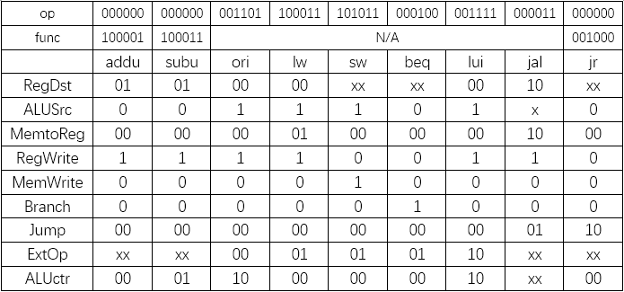

其中b_type:beq, jr; cal_r:addu, subu; cal_i:ori, lui; ld:lw; st:sw, jw:jal

1. 冲突模块设计

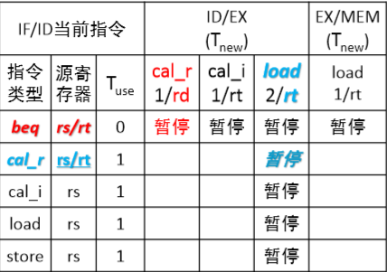

暂停模块设计如图，jal指令不涉及暂停操作，判断暂停条件如下：

assign stall_b=b_type&cal_r_E&((IR_D[`rs]==IR_E[`rd])|(IR_D[`rt]==IR_E[`rd]))|

b_type&cal_i_E&((IR_D[`rs]==IR_E[`rt])|(IR_D[`rt]==IR_E[`rt]))|

b_type&ld_E&((IR_D[`rs]==IR_E[`rt])|(IR_D[`rt]==IR_E[`rt]))|

b_type&ld_M&((IR_D[`rs]==IR_M[`rt])|(IR_D[`rt]==IR_M[`rt]));

assign stall_cal_r=cal_r_D&ld_E&((IR_D[`rs]==IR_E[`rt])|(IR_D[`rt]==IR_E[`rt]));

assign stall_cal_i=cal_i_D&ld_E&(IR_D[`rs]==IR_E[`rt]);

assign stall_ld=ld_D&ld_E&(IR_D[`rs]==IR_E[`rt]);

assign stall_st=st_D&ld_E&(IR_D[`rs]==IR_E[`rt]);

assign stall=stall_b|stall_cal_r|stall_cal_i|stall_ld|stall_st;

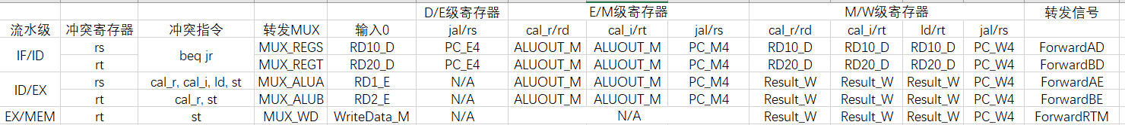

转发来源如图，代码设计：

assign ForwardAD=

b_type&cal_r_M&IR_D[`rs]!=0&IR_D[`rs]==IR_M[`rd]?1:

b_type&cal_i_M&IR_D[`rs]!=0&IR_D[`rs]==IR_M[`rt]?1:

b_type&cal_r_W&IR_D[`rs]!=0&IR_D[`rs]==IR_W[`rd]?2:

b_type&cal_i_W&IR_D[`rs]!=0&IR_D[`rs]==IR_W[`rt]?2:

b_type& ld_W &IR_D[`rs]!=0&IR_D[`rs]==IR_W[`rt]?2:

b_type&jw_E &IR_D[`rs]== 31 ?3:

b_type&jw_M &IR_D[`rs]== 31 ?4:

b_type&jw_W &IR_D[`rs]== 31 ?5:0;

assign ForwardBD=

b_type&cal_r_M&IR_D[`rt]!=0&IR_D[`rt]==IR_M[`rd]?1:

b_type&cal_i_M&IR_D[`rt]!=0&IR_D[`rt]==IR_M[`rt]?1:

b_type&cal_r_W&IR_D[`rt]!=0&IR_D[`rt]==IR_W[`rd]?2:

b_type&cal_i_W&IR_D[`rt]!=0&IR_D[`rt]==IR_W[`rt]?2:

b_type& ld_W &IR_D[`rt]!=0&IR_D[`rt]==IR_W[`rt]?2:

b_type&jw_E &IR_D[`rt]== 31 ?3:

b_type&jw_M &IR_D[`rt]== 31 ?4:

b_type&jw_W &IR_D[`rt]== 31 ?5:0;

assign ForwardAE=

(cal_r_E|cal_i_E|ld_E|st_E)&cal_r_M&IR_E[`rs]!=0&IR_E[`rs]==IR_M[`rd]?1:

(cal_r_E|cal_i_E|ld_E|st_E)&cal_i_M&IR_E[`rs]!=0&IR_E[`rs]==IR_M[`rt]?1:

(cal_r_E|cal_i_E|ld_E|st_E)&cal_r_W&IR_E[`rs]!=0&IR_E[`rs]==IR_W[`rd]?2:

(cal_r_E|cal_i_E|ld_E|st_E)&cal_i_W&IR_E[`rs]!=0&IR_E[`rs]==IR_W[`rt]?2:

(cal_r_E|cal_i_E|ld_E|st_E)& ld_W &IR_E[`rs]!=0&IR_E[`rs]==IR_W[`rt]?2:

(cal_r_E|cal_i_E|ld_E|st_E)&jw_M &IR_E[`rs]==31 ?3:

(cal_r_E|cal_i_E|ld_E|st_E)&jw_W &IR_E[`rs]==31 ?4:0;

assign ForwardBE=

(cal_r_E|st_E)&cal_r_M&IR_E[`rt]!=0&IR_E[`rt]==IR_M[`rd]?1:

(cal_r_E|st_E)&cal_i_M&IR_E[`rt]!=0&IR_E[`rt]==IR_M[`rt]?1:

(cal_r_E|st_E)&cal_r_W&IR_E[`rt]!=0&IR_E[`rt]==IR_W[`rd]?2:

(cal_r_E|st_E)&cal_i_W&IR_E[`rt]!=0&IR_E[`rt]==IR_W[`rt]?2:

(cal_r_E|st_E)& ld_W &IR_E[`rt]!=0&IR_E[`rt]==IR_W[`rt]?2:

(cal_r_E|st_E)&jw_M &IR_E[`rt]==31 ?3:

(cal_r_E|st_E)&jw_W &IR_E[`rt]==31 ?4:0;

assign ForwardRTM=

st_M&cal_r_W&IR_M[`rt]!=0&IR_M[`rt]==IR_W[`rd]?1:

st_M&cal_i_W&IR_M[`rt]!=0&IR_M[`rt]==IR_W[`rt]?1:

st_M& ld_W &IR_M[`rt]!=0&IR_M[`rt]==IR_W[`rt]?1:

st_M&jw_W &IR_M[`rt]==31 ?2:0;

1. CPU测试

测试代码：

#jr

jal lable6

ori $s1,$zero,4768

addu $s1,$s1,$zero

jr $ra

ori $s1,$zero,347

lui $s2,1

addu $s3,$s1,$s2

lable6:

ori $s1,$zero,3214

jal lable8

nop

ori $s2,$s3,0

addu $s2,$s2,$zero

j end

nop

lable8:

ori $s3,$zero,12324

jr $s3

ori $s3,$zero,43

addu $s3,$s3,$zero

end:

addu $s1,$zero,$zero

jal lable9

ori $s1,$zero,34

addu $s1,$s1,$zero

addu $s2,$s1,$s1

j main

nop

lable9:

jr $ra

nop

main:

#sw

ori $s0,100

sw $s0,0($zero)

sw $s0,4($zero)

ori $s1,$zero,200

addu $s1,$s1,$zero

sw $s1,8($zero)

sw $s1,12($zero)

lui $s2,2

sw $s2,16($zero)

sw $s2,20($zero)

addu $s2,$s1,$s0

sw $s2,24($zero)

sw $s2,28($zero)

subu $s3,$s2,$s1

sw $s3,32($zero)

sw $s3,36($zero)

jal lable1

lable1:

sw $ra,40($zero)

sw $ra,44($zero)

lw $s5,44($zero)

sw $s5,48($zero)

sw $s5,52($zero)

#addu

ori $s0,201

addu $s1,$s0,$s0

addu $s2,$s1,$s0

lui $s1,3

addu $s2,$s1,$s0

addu $s3,$s1,$s2

subu $s4,$s3,$s3

addu $s5,$s4,$s3

addu $s6,$s5,$s4

addu $s6,$s5,$s5

addu $s7,$s6,$s5

addu $s7,$s7,$s6

lw $s3,36($zero)

addu $s4,$s3,$s3

addu $s5,$s4,$s3

jal lable2

lable2:

addu $s0,$ra,$ra

addu $s1,$ra,$s0

#subu

ori $s0,326

subu $s1,$s0,$s0

subu $s2,$s1,$s0

lui $s1,3

subu $s2,$s1,$s0

subu $s3,$s1,$s2

subu $s4,$s3,$s3

subu $s5,$s4,$s3

subu $s6,$s5,$s4

addu $s6,$s5,$s5

subu $s7,$s6,$s5

subu $s7,$s7,$s6

lw $s3,36($zero)

subu $s4,$s3,$s3

subu $s5,$s4,$s3

jal lable3

lable3:

subu $s0,$ra,$ra

subu $s1,$ra,$s0

#ori

ori $s0,201

ori $s1,$s0,327

ori $s2,$s0,236

lui $s1,3

ori $s2,$s1,327

ori $s3,$s1,236

subu $s4,$s3,$s3

ori $s5,$s4,2442

ori $s6,$s4,32

addu $s6,$s5,$s5

ori $s6,$s6,213

ori $s7,$s6,432

lw $s3,52($zero)

ori $s4,$s3,56

ori $s5,$s3,432

jal lable4

lable4:

ori $s0,$ra,4231

ori $s1,$ra,234

#lui(无）

#lw

ori $s0,$zero,324

lw $s1,0($s0)

lw $s2,4($s0)

addu $s1,$s1,$s0

lw $s2,8($s1)

lw $s3,12($s1)

subu $s2,$s1,$s0

lw $s3,16($s2)

lw $s4,20($s2)

lui $s3,1

lw $s4,24($zero)

lw $s5,28($zero)

lw $s1,32($zero)

lw $s5,36($s1)

lw $s6,40($s1)

jal lable5

lable5:

lw $s0,0($s0)

#beq&j

ori $t1,$zero,5

addu $s0,$zero,$t1

ori $s1,$zero,0

for_1_begin:

beq $s1,$s0,for_1_end

ori $t1,$zero,50

subu $s2,$s3,$t1

ori $t1,$zero,1

addu $s1,$s1,$t1

j for_1_begin

for_1_end:

ori $t1,$zero,5

addu $s0,$zero,$t1

ori $s1,$zero,0

for_2_begin:

beq $s0,$s1,for_2_end

ori $t1,$zero,50

subu $s2,$s3,$t1

ori $t1,$zero,1

addu $s1,$s1,$t1

j for_2_begin

for_2_end:

ori $t1,$zero,5

addu $s0,$zero,$t1

sw $s0,56($zero)

lw $s0,56($zero)

ori $s1,$zero,0

for_3_begin:

beq $s1,$s0,for_3_end

ori $t1,$zero,50

subu $s2,$s3,$t1

ori $t1,$zero,1

addu $s1,$s1,$t1

j for_3_begin

for_3_end:

ori $s1,$zero,5

subu $s2,$s1,4

for_4_begin:

beq $s1,$s2,for_4_end

subu $s5,$s4,$s2

ori $t1,$zero,1

addu $s2,$s2,$t1

j for_4_begin

for_4_end:

ori $s0,$zero,0

ori $s1,$zero,6

测试期望：

90@00003000: $31 <= 00003008

110@00003004: $17 <= 000012a0

130@0000301c: $17 <= 00000c8e

150@00003020: $31 <= 00003028

190@00003038: $19 <= 00003024

250@00003040: $19 <= 0000002b

290@00003028: $18 <= 0000002b

310@0000302c: $18 <= 0000002b

370@00003048: $17 <= 00000000

390@0000304c: $31 <= 00003054

410@00003050: $17 <= 00000022

470@00003054: $17 <= 00000022

490@00003058: $18 <= 00000044

550@0000306c: $16 <= 00000064

550@00003070: *00000000 <= 00000064

570@00003074: *00000004 <= 00000064

610@00003078: $17 <= 000000c8

630@0000307c: $17 <= 000000c8

630@00003080: *00000008 <= 000000c8

650@00003084: *0000000c <= 000000c8

690@00003088: $18 <= 00020000

690@0000308c: *00000010 <= 00020000

710@00003090: *00000014 <= 00020000

750@00003094: $18 <= 0000012c

750@00003098: *00000018 <= 0000012c

770@0000309c: *0000001c <= 0000012c

810@000030a0: $19 <= 00000064

810@000030a4: *00000020 <= 00000064

830@000030a8: *00000024 <= 00000064

870@000030ac: $31 <= 000030b4

870@000030b0: *00000028 <= 000030b4

890@000030b0: *00000028 <= 000030b4

910@000030b4: *0000002c <= 000030b4

950@000030b8: $21 <= 000030b4

950@000030bc: *00000030 <= 000030b4

970@000030c0: *00000034 <= 000030b4

1010@000030c4: $16 <= 000000ed

1030@000030c8: $17 <= 000001da

1050@000030cc: $18 <= 000002c7

1070@000030d0: $17 <= 00030000

1090@000030d4: $18 <= 000300ed

1110@000030d8: $19 <= 000600ed

1130@000030dc: $20 <= 00000000

1150@000030e0: $21 <= 000600ed

1170@000030e4: $22 <= 000600ed

1190@000030e8: $22 <= 000c01da

1210@000030ec: $23 <= 001202c7

1230@000030f0: $23 <= 001e04a1

1250@000030f4: $19 <= 00000064

1290@000030f8: $20 <= 000000c8

1310@000030fc: $21 <= 0000012c

1330@00003100: $31 <= 00003108

1350@00003104: $16 <= 00006210

1370@00003104: $16 <= 00006210

1390@00003108: $17 <= 00009318

1410@0000310c: $16 <= 00006356

1430@00003110: $17 <= 00000000

1450@00003114: $18 <= ffff9caa

1470@00003118: $17 <= 00030000

1490@0000311c: $18 <= 00029caa

1510@00003120: $19 <= 00006356

1530@00003124: $20 <= 00000000

1550@00003128: $21 <= ffff9caa

1570@0000312c: $22 <= ffff9caa

1590@00003130: $22 <= ffff3954

1610@00003134: $23 <= ffff9caa

1630@00003138: $23 <= 00006356

1650@0000313c: $19 <= 00000064

1690@00003140: $20 <= 00000000

1710@00003144: $21 <= ffffff9c

1730@00003148: $31 <= 00003150

1750@0000314c: $16 <= 00000000

1770@0000314c: $16 <= 00000000

1790@00003150: $17 <= 00003150

1810@00003154: $16 <= 000000c9

1830@00003158: $17 <= 000001cf

1850@0000315c: $18 <= 000000ed

1870@00003160: $17 <= 00030000

1890@00003164: $18 <= 00030147

1910@00003168: $19 <= 000300ec

1930@0000316c: $20 <= 00000000

1950@00003170: $21 <= 0000098a

1970@00003174: $22 <= 00000020

1990@00003178: $22 <= 00001314

2010@0000317c: $22 <= 000013d5

2030@00003180: $23 <= 000013f5

2050@00003184: $19 <= 000030b4

2090@00003188: $20 <= 000030bc

2110@0000318c: $21 <= 000031b4

2130@00003190: $31 <= 00003198

2150@00003194: $16 <= 0000319f

2170@00003194: $16 <= 0000319f

2190@00003198: $17 <= 000031fa

2210@0000319c: $16 <= 00000144

2230@000031a0: $17 <= 00000000

2250@000031a4: $18 <= 00000000

2270@000031a8: $17 <= 00000144

2290@000031ac: $18 <= 00000000

2310@000031b0: $19 <= 00000000

2330@000031b4: $18 <= 00000000

2350@000031b8: $19 <= 00020000

2370@000031bc: $20 <= 00020000

2390@000031c0: $19 <= 00010000

2410@000031c4: $20 <= 0000012c

2430@000031c8: $21 <= 0000012c

2450@000031cc: $17 <= 00000064

2490@000031d0: $21 <= 00000000

2510@000031d4: $22 <= 00000000

2530@000031d8: $31 <= 000031e0

2550@000031dc: $16 <= 00000000

2590@000031dc: $16 <= 00000064

2610@000031e0: $ 9 <= 00000005

2630@000031e4: $16 <= 00000005

2650@000031e8: $17 <= 00000000

2710@000031f0: $ 9 <= 00000032

2730@000031f4: $18 <= 0000ffce

2750@000031f8: $ 9 <= 00000001

2770@000031fc: $17 <= 00000001

2810@00003204: $ 9 <= 00000005

2850@000031f0: $ 9 <= 00000032

2870@000031f4: $18 <= 0000ffce

2890@000031f8: $ 9 <= 00000001

2910@000031fc: $17 <= 00000002

2950@00003204: $ 9 <= 00000005

2990@000031f0: $ 9 <= 00000032

3010@000031f4: $18 <= 0000ffce

3030@000031f8: $ 9 <= 00000001

3050@000031fc: $17 <= 00000003

3090@00003204: $ 9 <= 00000005

3130@000031f0: $ 9 <= 00000032

3150@000031f4: $18 <= 0000ffce

3170@000031f8: $ 9 <= 00000001

3190@000031fc: $17 <= 00000004

3230@00003204: $ 9 <= 00000005

3270@000031f0: $ 9 <= 00000032

3290@000031f4: $18 <= 0000ffce

3310@000031f8: $ 9 <= 00000001

3330@000031fc: $17 <= 00000005

3370@00003204: $ 9 <= 00000005

3410@000031f0: $ 9 <= 00000032

3430@00003204: $ 9 <= 00000005

3450@00003208: $16 <= 00000005

3470@0000320c: $17 <= 00000000

3530@00003214: $ 9 <= 00000032

3550@00003218: $18 <= 0000ffce

3570@0000321c: $ 9 <= 00000001

3590@00003220: $17 <= 00000001

3630@00003228: $ 9 <= 00000005

3670@00003214: $ 9 <= 00000032

3690@00003218: $18 <= 0000ffce

3710@0000321c: $ 9 <= 00000001

3730@00003220: $17 <= 00000002

3770@00003228: $ 9 <= 00000005

3810@00003214: $ 9 <= 00000032

3830@00003218: $18 <= 0000ffce

3850@0000321c: $ 9 <= 00000001

3870@00003220: $17 <= 00000003

3910@00003228: $ 9 <= 00000005

3950@00003214: $ 9 <= 00000032

3970@00003218: $18 <= 0000ffce

3990@0000321c: $ 9 <= 00000001

4010@00003220: $17 <= 00000004

4050@00003228: $ 9 <= 00000005

4090@00003214: $ 9 <= 00000032

4110@00003218: $18 <= 0000ffce

4130@0000321c: $ 9 <= 00000001

4150@00003220: $17 <= 00000005

4190@00003228: $ 9 <= 00000005

4230@00003214: $ 9 <= 00000032

4250@00003228: $ 9 <= 00000005

4270@0000322c: $16 <= 00000005

4270@00003230: *00000038 <= 00000005

4310@00003234: $16 <= 00000005

4330@00003238: $17 <= 00000000

4390@00003240: $ 9 <= 00000032

4410@00003244: $18 <= 0000ffce

4430@00003248: $ 9 <= 00000001

4450@0000324c: $17 <= 00000001

4490@00003254: $17 <= 00000005

4550@00003240: $ 9 <= 00000032

4570@00003254: $17 <= 00000005

4590@00003258: $ 1 <= 00000000

4610@0000325c: $ 1 <= 00000004

4630@00003260: $18 <= 00000001

4690@00003268: $21 <= 0000012b

4710@0000326c: $ 9 <= 00000001

4730@00003270: $18 <= 00000002

4770@00003278: $16 <= 00000000

4810@00003268: $21 <= 0000012a

4830@0000326c: $ 9 <= 00000001

4850@00003270: $18 <= 00000003

4890@00003278: $16 <= 00000000

4930@00003268: $21 <= 00000129

4950@0000326c: $ 9 <= 00000001

4970@00003270: $18 <= 00000004

5010@00003278: $16 <= 00000000

5050@00003268: $21 <= 00000128

5070@0000326c: $ 9 <= 00000001

5090@00003270: $18 <= 00000005

5130@00003278: $16 <= 00000000

5170@00003268: $21 <= 00000127

5190@00003278: $16 <= 00000000

5210@0000327c: $17 <= 00000006

1. 思考题

1. 在本实验中你遇到了哪些不同指令组合产生的冲突？你又是如何解决的？相应的测试样例是什么样的？请有条理的罗列出来。

测试类型R_M_RS subu $1, $2, $3

addu $4, $1, $2

R_M_RT subu $1, $2, $3

addu $4, $2, $3

R_W_RS subu $1, $2, $3

Instr无关

addu $4, $1, $2

R_M_RT subu $1, $2, $3

Instr无关

Addu $4, $1, $2

I_M_RS ori $1, $2, 100

Addu $4, $1, $2

I_M_RT ori $1, $2, 100

Addu $4, $2, $1

I_W_RS ori $1, $2, 100

Instr无关

Addu $4, $1, $2

I_W_RT lw $1, 0($0)

Instr无关

Addu $4, $2, $1

LD_M_RS lw $1, 0($0)

Addu $4, $1, $2

LD_M_RT lw $1, 0($0)

Addu $4, $2, $1

LD_W_RS lw $1, 0($0)

Instr无关

Addu $4, $1, $2

LD_W_RT lw $1, 0($0)

Instr无关

Addu $4, $2, $1

ST_W_RD Addu $4, $1, $2

Instr无关

sw $4, 0($0)

B_M_RS subu $4, $1, $2

Instr无关

Beq $4, $5, label

B_M_RT subu $4, $1, $2

Instr无关

Beq $5, $4, label

B_W_RS subu $4, $1, $2

Instr无关

Beq $4, $5, label

B_W_RT subu $4, $1, $2

Instr无关

Beq $5, $4, label

除了以上转发情况，还有暂停情况：

Addu $1, $2, $3

Beq $1, $4, label

Ori $1, $0, 5

Beq $1, $0, label

Lw $5, 0($0)

Beq $5, $4, label

Lw $2, 0($0)

Instr 无关

Beq $3, $2, label

Lw $2, 0($0)

Addu $4, $2, $3

Lw $2, 0($0)

ori $4, $2, 5

Lw $2, 0($0)

Lw $3, 0($2)

Lw $2, 0($0)

sw $3, 0($2)